

Veriton 4000 Compact Tower

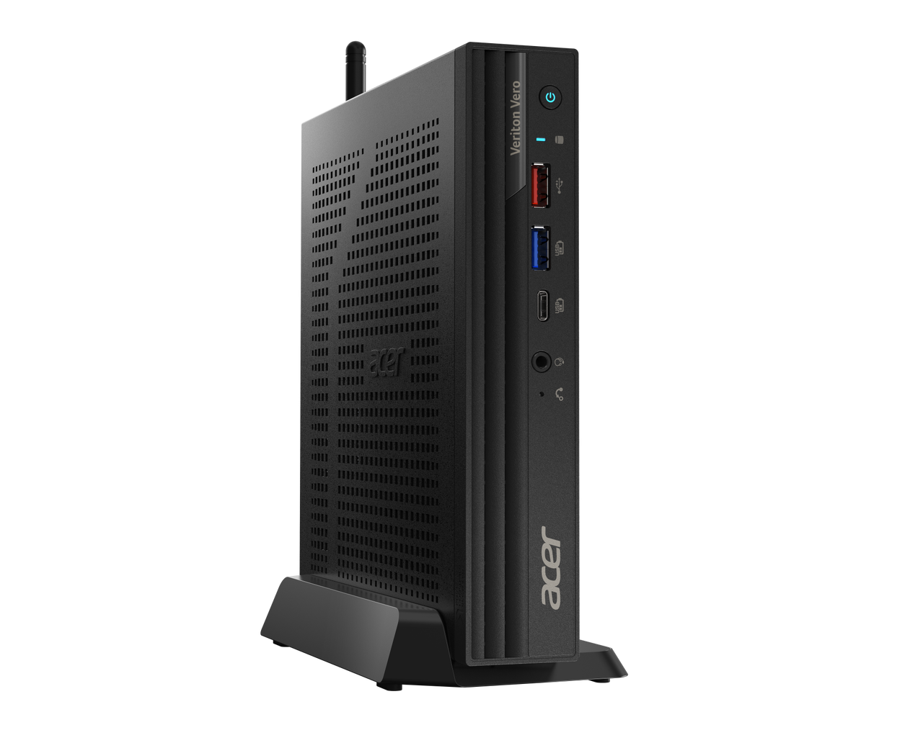
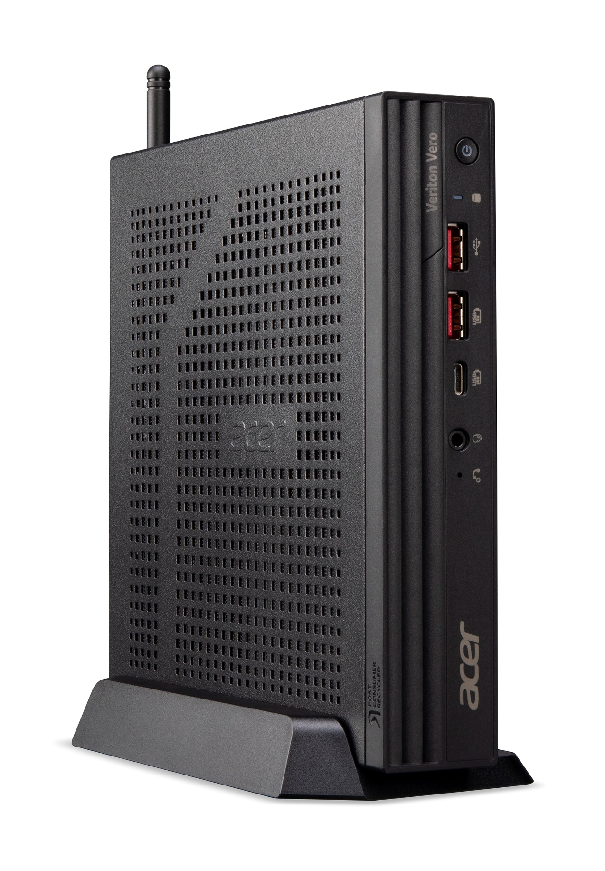
Veriton Vero 4000 Mini
Veriton Vero 6000 Mini
Veriton 4000 Compact Tower

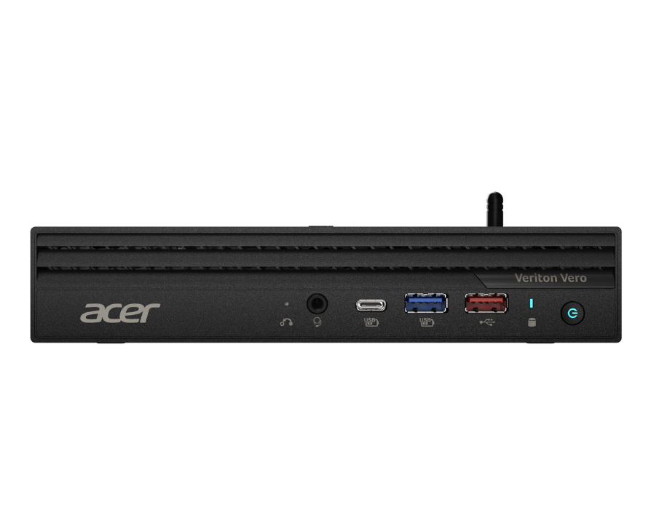
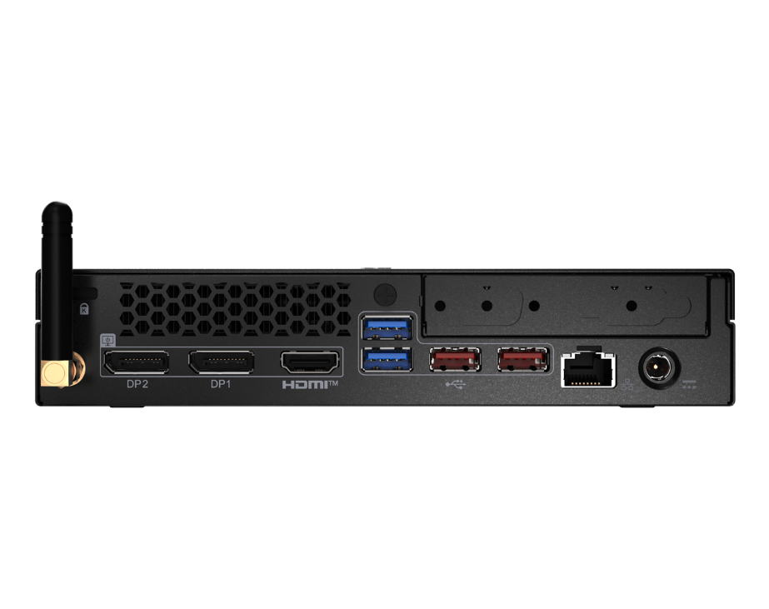
SPECIFICATIONS Veriton VN4725G | VN4725GT | VN6725G | VN6725GT

1
2
3
4
6
5

Product views | - One button recovery  - Universal audio jack  - USB 3.2 Gen2x2 (20 Gbps) Type-CTM port  - USB 3.2 Gen 1 (5 Gbps) Type-A port  - USB 3.2 Gen 2 (10 Gbps) Type-A port  - Power button |  | - External Antenna (optional)  - Kensington lock slot  - DisplayPort™  - DisplayPort™  - HDMI® port  - 2 x USB 3.2 Gen 1 (5Gbps) Type-A ports  - 2x USB 3.2 Gen2 (10Gbps) Type-A (6000)  2X USB 2.0 (480Mbps) Type-A (4000) |  | - Ethernet RJ45 LAN port  - Power connector (DC-in)  - Optional port (refer to Commercial selected options)  - COM¹ Port (refer to Commercial selected options)
Operating system^{1, 2} | Windows 11 Pro 64-bit (Acer recommends Windows 11 Pro for business.)  Windows 11 Home 64-bit  UEFI Shell
CPU and chipset¹ | VN6725G(T)  •Intel® Core™ i9 vPro® 14th gen processors, Intel® UHD Graphics770  •Intel® Core™ i7 vPro® 14th gen processors, Intel® UHD Graphics 770  •Intel® Core™ i5 vPro® 14th gen processors, Intel® UHD Graphics 770  Chipset: Intel® Q670 | •Intel® Core™ i9 14th gen processors, Intel® UHD Graphics 770  •Intel® Core™ i7 14th gen processors, Intel® UHD Graphics 770  •Intel® Core™ i5 14th gen processors, Intel® UHD Graphics 770 |  | VN4725G(T)  •Intel® Core™ i9 14th gen processors, Intel® UHD Graphics 770  •Intel® Core™ i7 14th gen processors, Intel® UHD Graphics 770  •Intel® Core™ i5 14th gen processors, Intel® UHD Graphics 770  •Intel® Core™ i3 14th gen processors, Intel® UHD Graphics 770  Intel® B760
Memory^{1, 3, 4} | 32 GB DDR5 5600 MT/S soDIMM  16 GB DDR5 5600 MT/S soDIMM  8 GB DDR5 5600 MT/S soDIMM  Up to 64 GB of Dual-channel DDR5 5600 MT/S
Storage^{1, 5} | Hard disk drive:  - 2048 GB / 1024 GB / 512 GB M.2 2280 PCI-e Gen4 Performance SSD  - 1024 GB / 512 GB / 256 GB M.2 2280 PCI-e Gen4 SSD
Audio | Integrated high-definition sound
Communication | WLAN:  802.11be/ax/ac/a/b/g/n, Wi-Fi 7 and Bluetooth® 5.4  802.11ax/ac/a/b/g/n, Wi-Fi 6E and Bluetooth® 5.3 |  |  | LAN:  Gigabit Ethernet
Expansion slot(s) | M.2 slot (for SSD): 2  M.2 slot (for WLAN): 1
Commercial features^{6,7} | VN4725G(T)  TPM v2.0 (Trusted Platform Module)  Intrusion alert (via BIOS)  Hard drive password protection (via BIOS)  One-button recovery (OBR)  WOL (Wake On Lan)  PXE (Preboot eXecution Environment)  Kensington lock slot |  |  | VN6725G(T)  TPM v2.0 (Trusted Platform Module)  Intrusion alert (via BIOS)  Hard drive password protection (via BIOS)  One-button recovery (OBR)  WOL (Wake On Lan)  PXE (Preboot eXecution Environment)  Kensington lock slot  Intel® Active Management Technology  Intel® vPro™ Technology  RAID support (via BIOS)
Commercial selected options⁸ | Additional D-SUB port  Additional 2nd HDMI® port  Additional 2.5G LAN port  Additional USB Type-A 3.2 Gen 2 port  USB 3.2 Gen 2 Type-C port supporting data transfer, 5V/3A USB charger, video output and 100W PD-in  USB 3.2 Gen 2 Type-C port supporting data transfer, 5V/3A USB charger, and video output  Internal speaker  COM (Series) port
Dimensions and weight | Dimensions:  • 186.3 (W) x 186.3 (D) x 36.2 (H) mm (7.33 x 7.33 x 1.43 inches) |  |  | Weight:  • 1.3 kg (2.87 lbs.)
Power supply and battery | 3-pin 135 W AC adapter  3-pin 180 W AC adapter (by CTO request)
System compliance⁹ | RoHS, DMI, GS, ENERGY STAR®, PC2001, EPEAT Gold ® design (EPEAT registration varies by country)
Options and accessories | USB keyboard and mouse  VESA mount kit (100mm*100mm) (optional)
Certification | BSMI  VCCI  CE  FCC |  |  | CB  EPEAT Gold  TCO Certified
DISCLAIMERS
- Specifications vary depending on model.
- 64-bit software is required to enjoy the advantages of 64-bit processing.
- A 64-bit operating system is required to enjoy the ultimate performance of 4 GB or higher memory.
- Memory speed may vary, depending on the CPU, chipset or memory fitted.
- 1 GB is 1 billion bytes. Actual formatted capacity is less and may vary depending on preloaded materials and operating environment. Recovery Management uses a portion of the stated hard disk capacity as dedicated backup space.
- Intel® vPro™ technology is sophisticated and requires setup and activation. Availability of features and results will depend upon the setup and configuration of your hardware, software, and IT environment. To learn more visit Intel website.
- Intel® AMT is a feature of Intel® Core™ processors with Intel® vPro™ Technology
- Only one of the additional options can be selected.
- This is for 35W CPU sku and one of the option port can be selected
- EPEAT® registration varies by country and configuration. See http://www.epeat.net/ for registration status for each country
Product Sheet based on Veriton VN6725GTJ Specifications (v3-0-0) (Preview) and Veriton VN4725GT Specifications (v4-0-1) (Preview)

8
9
10
11
1222
7
15
1333
14
17
16

